2023_SKCET_Cloud_CC1Time:30 minutesMarks: 17Q3.

Create a S3 bucket for the following requirementsCreate a new S3 bucket in the region of "Stockholm".(4 Marks)

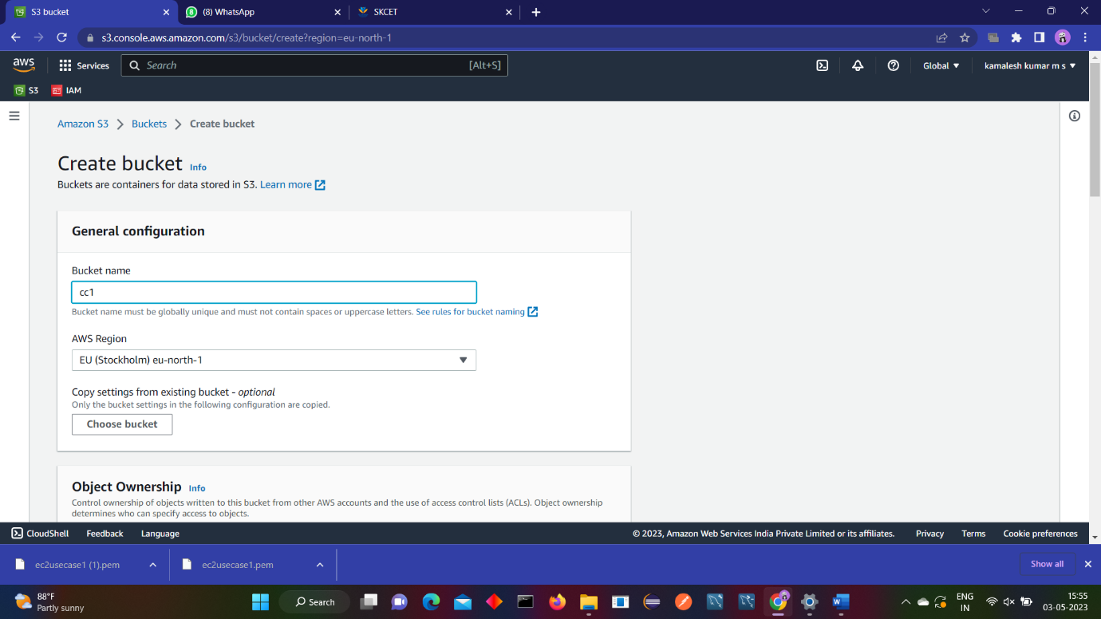

Make the bucket accessible to everyone(publicly) via Bucket ACL.(4 Marks)

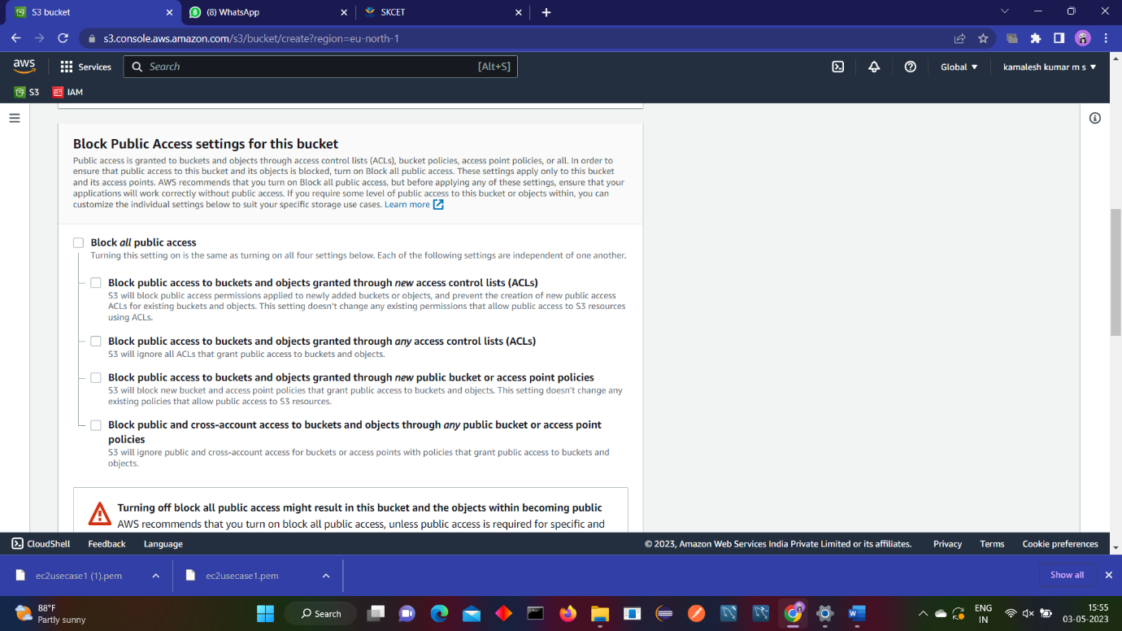

Upload a text file in the name of 'accounts.txt'. (5Marks)

Make the object 'accounts.txt' file accessible to everyone(publicly).(4 Marks)